Lesson 4 Content
Lesson 4: Loops and Working with 3D Space (2 hours)
Within the framework of the fourth lesson, we have decided to offer more freedom in the choice of activities and topics. This approach allows us to integrate various elements and concepts that might not have been included in previous lessons. After all, flexibility is often a key factor in effective learning. The activities in the first part of the lesson can be shortened or even skipped entirely if the teacher deems it necessary to devote more time to other important aspects.
In the second part of the lesson, the primary focus will be on loop structures in code. Students will learn how to effectively use loops in Roblox to create dynamic and interactive elements. Examples will be presented that demonstrate how to work with loops for moving objects, changing their coordinates, and other scenarios. This part will help students reinforce their knowledge of working with loop structures and coordinates, which is an important skill for any budding developer.

1. Introduction and Homework Review (20 minutes)
Greeting, attendance check, and discussion of homework. Give those who wish the opportunity to present their projects.

2. Coordinates. Practice. (15 minutes)
In this part of the lesson, we will dive into hands-on work with coordinates, using a specially prepared project called "Coordinates." Students will take turns trying to determine the coordinates of a sphere in 3D space. The project I have prepared for this lesson includes three coordinate axes and a sphere, which we are already familiar with from the previous lesson.
A key element is a button that can be clicked with the mouse. Upon clicking, the sphere will change its coordinates to random values that are multiples of 10, within a range of -50 to 50 along each axis. This adds an element of randomness and makes the task more interesting.
We will take turns calling students to the computer. Each will have the opportunity to control the character, rotate the camera, and try to determine the current coordinates of the sphere.
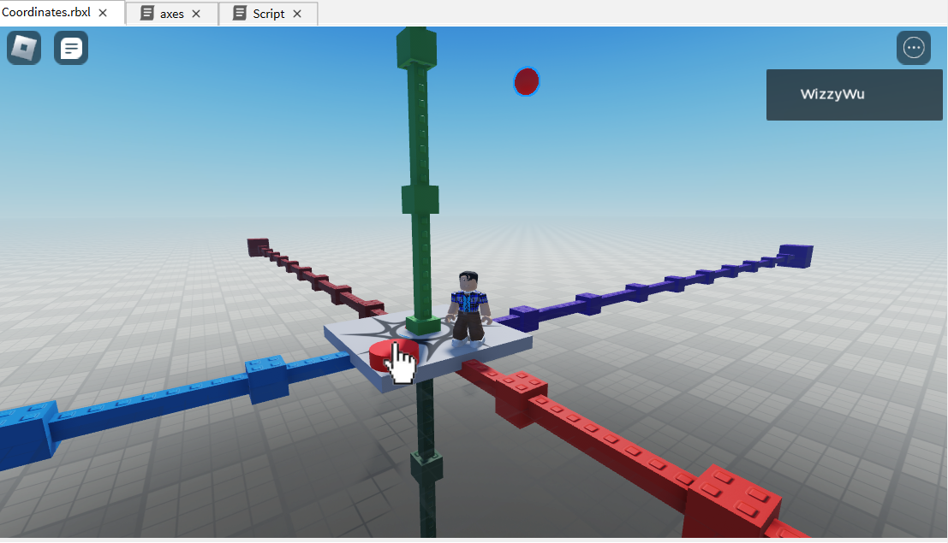

3. Theory: Loops (10 minutes)
What Are Loops and Where Are They Used?
Loops in programming are similar to film reels in old movies, spinning around and around, repeating each frame. They allow us to automate repetitive actions. For example, if you need to draw many stars on the screen, you don't have to draw each one individually. You can draw one star and then repeat that action in a loop 100 times.
Real-Life Examples
Loops are also prevalent in everyday life. When you wash your hands, you soap and rinse them several times. In school, lessons follow one after another, repeating the schedule each week. These are all examples of loops in action.
Counted Loops
Imagine you have a task to do 10 push-ups. You start with the first one, then the second, and so on up to the tenth. Here you have an explicit "counter"—the number of push-ups. In programming, counted loops work in much the same way. They execute a specific chunk of code a set number of times.
-- Counting from 1 to 10
for i = 1, 10, 1 do

end

Infinite Loops
Sometimes in programming, you need loops that can theoretically run indefinitely. It's like when you listen to a playlist on shuffle and don't know what song will be next. Such loops continue to run until they are explicitly stopped.
-- This will run indefinitely
while true do

end
Conditional Loops
Conditional loops are like the game "red light, green light." You move as long as the light is green (condition met), and you stop as soon as the light turns red (condition not met). In programming, such loops operate as long as a specific condition is met, for example, as long as a variable is less than a certain number.
-- Initialize counter
local counter = 0

-- Loop while counter is less than 5
while counter < 5 do
print("Counter is at: " .. counter)
counter = counter + 1 -- Increment the counter
end
-- Initialize counter
local counter = 0

-- Loop until counter reaches 5
repeat
print("Counter is at: " .. counter)
counter = counter + 1 -- Increment the counter
until counter >= 5
So, loops are a powerful tool in programming that allow for the simplification and automation of numerous tasks!

4. Practice (10 minutes)
We will implement platform movement using a loop. We'll take an example of a moving platform from a previous lesson:
local p3 = game.Workspace.Panel3
function onTouch()
p3.Position = Vector3.new(19, 1.5, 128)
wait(0.3)

p3.Position = Vector3.new(15, 1.5, 128)
wait(0.3)

p3.Position = Vector3.new(10, 1.5, 128)
wait(0.3)

p3.Position = Vector3.new(5, 1.5, 128)
wait(0.3)

p3.Position = Vector3.new(0, 1.5, 128)
wait(0.3)

p3.Position = Vector3.new(-5, 1.5, 128)
wait(0.3)
end

game.Workspace.Bt1.Touched:Once(onTouch)
We'll isolate the repeating part and write it in the form of a loop with a counter because we know in advance that the loop will repeat 6 times.
local p3 = game.Workspace.Panel3

function onTouch()
for i = 19, -5, -5 do
p3.Position = Vector3.new(i, 1.5, 128)
wait(0.3)
end
end

game.Workspace.Bt1.Touched:Once(onTouch)
The loop starts with this line: `for i = 19, -5, -5 do`. Let's break down what's happening here:
- `i = 19`: This is the initial value of the variable `i`. The first time the loop starts, `i` will be equal to 19.
- `-5`: This is the end value. The loop will continue to repeat until `i` reaches this value.
- `-5`: This is the step. After each iteration of the loop, the value of `i` decreases by 5.
So, in this loop, `i` changes as follows: it starts at 19, then goes to 14 (19 - 5), then to 9 (14 - 5), and so on until `i` becomes less than or equal to -5.
Each time the loop iterates, we change the position of the panel `p3` to `Vector3.new(i, 1.5, 128)` and wait for 0.3 seconds. This creates an animation of the panel moving from one point to another.
Now, let's take the variables out of the function for greater flexibility.
local p3 = game.Workspace.Panel3
local step = -5
local delay = 0.3

function onTouch()
for i = 19, -5, step do
p3.Position = Vector3.new(i, 1.5, 128)
wait(delay)
end
end

game.Workspace.Bt1.Touched:Once(onTouch)
We'll play with the variables for smoother animation.
local p3 = game.Workspace.Panel3
local step = -0.5
local delay = 0.1

function onTouch()
for i = 19, -5, step do
p3.Position = Vector3.new(i, 1.5, 128)
wait(delay)
end
end

game.Workspace.Bt1.Touched:Once(onTouch)
Using loops significantly simplifies the process of creating animations or repeating actions in code. Without loops, we would have to copy and paste similar lines of code multiple times, making the code cumbersome and hard to read. With loops, everything becomes much simpler and more elegant.

5. Change (10 minutes)

6. Practical Part: Independent Work (20 minutes)
Implementation of a platform that moves towards and away from us 10 times.
First, let's propose to the children to implement the movement towards and away from us, and then repeat it several times.
Example Implementation:
local platform = game.Workspace.Platform

function movePlatform()
for pos = 271.5, 321.5, 1 do
platform.Position = Vector3.new(-40.5, 1.5, pos)
wait(0.1)
end

for pos = 321.5, 271.5, -1 do
platform.Position = Vector3.new(-40.5, 1.5, pos)
wait(0.1)
end
end

for i = 1, 10 do
movePlatform()
end

Draw the children's attention to an interesting point: when the platform is moving, you somehow need to constantly run on it, otherwise it slips away from under your feet. This happens because the platform doesn't move continuously from point A to point B. It actually "teleports" very short distances. These movements are so fast and insignificant that they seem continuous, but for a character in the game, it's like many small teleports. Therefore, staying on it is a real challenge!

7. Using an Infinite Loop (5 minutes)
We improve the previous example by using an infinite loop.
local platform = game.Workspace.Platform

function movePlatform()
for pos = 271.5, 321.5, 1 do
platform.Position = Vector3.new(-40.5, 1.5, pos)
wait(0.1)
end

for pos = 321.5, 271.5, -1 do
platform.Position = Vector3.new(-40.5, 1.5, pos)
wait(0.1)
end
end

while true do
movePlatform()
end

8. Using an Item that Moves and Inflicts Damage
- Find a ready-made item in the Battle Axe collection.
- Create a scene by adding a path, a column, and an axe. Duplicate the column and axe along the path.
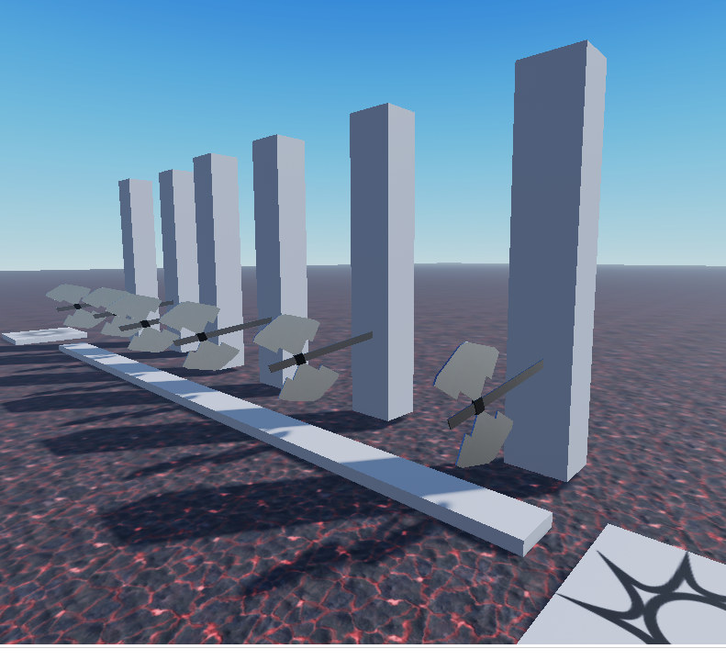
- Our task is to write 2 functions:
  - The first function inflicts damage on the character upon contact, similar to lava.
  - The second function moves the axe up and down indefinitely.
  - Attach these two functions to all the axes.
- Implementation:
function moveAxe(axe)
while true do
for i = 0, 10 do
axe.Position = axe.Position + Vector3.new(0, 1, 0)
wait(0.03)
end
for i = 0, 10 do
axe.Position = axe.Position - Vector3.new(0, 1, 0)
wait(0.03)
end
end
end

function hit(player)
local pl = player.Parent:FindFirstChild("Humanoid")
pl.Health = 0
end

local axe1 = game.Workspace.Axe1
local axe2 = game.Workspace.Axe2
local axe3 = game.Workspace.Axe3
local axe4 = game.Workspace.Axe4
local axe5 = game.Workspace.Axe5
local axe6 = game.Workspace.Axe6

axe1.Touched:Connect(hit)
axe2.Touched:Connect(hit)
axe3.Touched:Connect(hit)
axe4.Touched:Connect(hit)
axe5.Touched:Connect(hit)
axe6.Touched:Connect(hit)

coroutine.wrap(moveAxe)(axe1)
coroutine.wrap(moveAxe)(axe2)
coroutine.wrap(moveAxe)(axe3)
coroutine.wrap(moveAxe)(axe4)
coroutine.wrap(moveAxe)(axe5)
coroutine.wrap(moveAxe)(axe6)

-- moveAxe(axe1)
-- moveAxe(axe2)
-- moveAxe(axe3)
-- moveAxe(axe4)
-- moveAxe(axe5)
-- moveAxe(axe6)
In the initial version of the code, we used a simple function call, `moveAxe(axe1)`, to move the axe. This approach is intuitive, especially for children, and is similar to what we've done before. However, as you may have noticed, this method has a significant drawback: only one axe moves.
The problem here is that each call to the `moveAxe` function gets stuck in an infinite loop with `while true do`. As a result, the first axe starts moving, but the code never moves on to the subsequent axes because the first infinite loop keeps running.
The solution to this issue is to use coroutines with the `coroutine.wrap(moveAxe)(axe1)` construct. This line of code creates a new execution thread specific to each axe, allowing each axe to move independently from the others.
In `coroutine.wrap(moveAxe)`, we pass the name of the `moveAxe` function that we want to execute in a separate thread. Then, using the parentheses at the end of `coroutine.wrap(moveAxe)(axe1)`, we pass `axe1` as an argument to this function. In this way, each axe gets its own "personal" infinite loop, running in parallel with others, which allows all axes to move simultaneously.

9. Homework (5 minutes)
Create your own obstacle course with protruding spikes, blades, falling blocks underfoot, and other dangerous items.

10. Feedback (5 minutes)
At the end of the lesson and upon completing independent tasks, it's important to gather feedback from the students. This helps to understand not only what was most useful and interesting for them but also to identify areas that may need improvement or further explanation.
Idea for conducting a feedback session:
Positive Point: Ask the children to take turns sharing what they liked most during the lesson. This could be a specific tool, effect, or just the general teaching approach.
Area for Improvement: Also, invite students to express what they did not like or what they think needs to be improved. This could be the complexity of the material, pace of teaching, or some technical aspects.
Summary: After everyone has spoken, draw conclusions. Note the general trends in the feedback and discuss what changes or improvements could be introduced in future lessons.
The feedback session is a valuable tool for the teacher, as it provides specific information about how the lesson was perceived by the students. This can also be a motivating factor for the children, as they see that their opinions are taken into account.

Обратная связь (5 минут)
Сессия обратной связи является ценным инструментом для учителя, так как она предоставляет конкретную информацию о том, как урок был воспринят учащимися. Это также может быть мотивирующим моментом для детей, поскольку они видят, что их мнение учитывается.

